

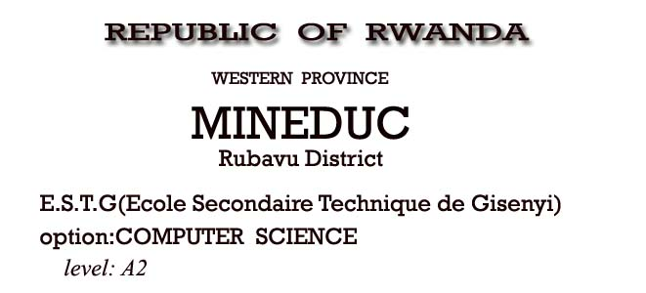

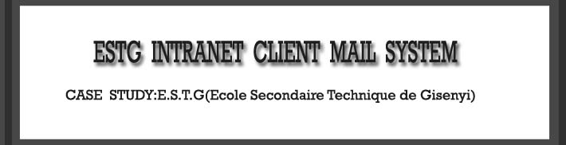

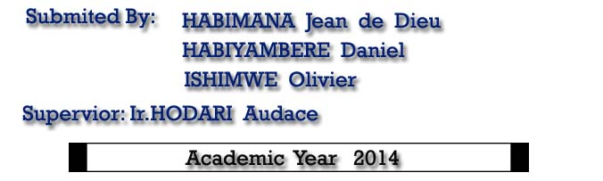

# DECLARATION

We, Habimana Jean de Dieu, Habiyambere Daniel**,** Ishimwe Olivier to the best of our knowledge hereby declare that, this project work entitled, “**ESTG INTRANET MAIL CLIENT SYSTEM”**  is original and has never been submitted to any high school or other institution, it is our own research where by other scholar’s writings were cited and references are provided.

**Habimana Jean de Dieu** Signature………………..

**Habiyambere Daniel**  Signature…………………

**Ishimwe Olivier** Signature………………….

**Supervisor: Ir. Hodari Audace**

Signature…………………….

Date…../….../2014

**CERTIFICATION**

This is to certify that the project entitled**” ESTG INTRANET MAIL CLIENT SYSTEM** ” is a record of original work done by **Habimana Jean de Dieu, Habiyambere Daniel, Ishimwe Olivier** in partial fulfillment of the requirement for A2 Certificate in Computer science.

……………………………………………………….. ………………………………………………………..

……………………………………………………….

**S**UPERVISOR**: Ir. H**ODARI **A**UDACE

# 



**ABSTRACT**

The purpose of this project is to improve the communication in ESTG. The main objective of this project is to facilitate to the members of ESTG to communicate each other.

This system can efficiently and effectively help all ESTG members to be able to communicate between them.

The achievement of this objective is described in the current project within its phases Such as requirement gathering, analysis, design, and implementation and testing. This project gives definition and theoretical concept of a window based application, provides both theoretical and practical conception of ESTG INTRANET MAIL CLIENT SYSTEM. By the end of this project, conclusion and recommendation

**ACKNOWLEDGEMENT**

We would like first to thank God Almighty who has always given us strength and been on our side throughout our studies.

Our heartfelt thanks to our families, whose financial sacrifice and moral support have helped us to carry out this research.

Our sincere gratitude is addressed to my lovely Aunt for the support provided to me, I always pray for her and asks the almighty God to blessing her

Our sincere gratitude is addressed to my lovely Grand Mother for the support provided to me, I always pray for her and asks the almighty God to blessing her

We express our sincere thanks to the government of Rwanda for providing and maintaining practical examination in secondary school through workforce development authority (WDA).

Our deep gratitude is addressed to for the knowledge they gave us, especially **Hodari Audace** our supervisor, who assisted me during this project work by offering wise advices, time and guidance towards the success of this project.

To all our classmates, colleagues and friends, and also to everyone who contributed nearly or far for this project.

*May God Bless You All!*

# 

# ACCRONYMS

**CMD**  : Conceptual Model of Data

**CSS** : Cascading Style Sheet

**CSC** : Computer Science

**DBMS**  : Database Management System

**ESTG**  : Ecole Secondary Technic Gisenyi

**EPR**  : Eglise Presbyterian au Rwanda

**GUI** : Graphical User Interface

**HTML** : Hypertext Markup Language

**HTTP** : Hyper Text Transfer Protocol

**ID**  : Identification

**IT**  : Information Technology

**ICT**  : Information Communication Technology

**LAN** : Local Area Network

**LMD** : Logical Model of Data

**PC** : Personal Computer

**PHP** : Personal Hypertext Preprocessor

**PMD** : Physical Model of Data

**RDBMS**  : Relational Database Management System

**W.D.A**  : Workforce Development Authority

**WAMP** : Windows Apache MySQL PHP

**WWW** : World Wide Web

**XAMP**  : eXtended Apache MySQL PHP

# 

# LIST OF FIGURES

Figure 1: Use case diagram for the Existing system 15

Figure2: Waterfall model 14

figure 3: Use case diagram for the new system. 16

Figure4: database relationship 17

Figure5: conceptual data model 20

Figure6: database processing system 20

Figure7 :Architecture design 25

Figure8: Project Requirements 26

Figure9: intranet organization 27

Figur10. Login Page 28

Figure 11:user page 29

Figure12: create account 29

Figure 13: about us 30

Figure14: contact us 31

Figure15: compose a message 32

Figure 16: inbox 33

Figure 17: sent message 34

Figure 18.admin 34

# LIST OF TABLES

Table1: user table 20

Table2: table of creating new account 21

table3:message table 21

Table4: comment table 21

Table5: admin table 22

Table 6: user 23

Table 7: create new account 23

Table 8: Message 24

Table 9: Comment 24

Table 10: Admin 24

# TABLE OF CONTENTS

DECLARATION i

ACCRONYMS v

LIST OF FIGURES vi

LIST OF TABLES vii

TABLE OF CONTENTS viii

CHAPTER ONE: GENERAL INTRODUCTION 1

1.1. INTRODUCTION 1

1.2. ESTG Background 2

1.3 PROBLEM STATEMENT 4

1.4. Objectives 4

1.4.1 General Objective 4

1.4.2 Specific Objectives 4

1.5. Scope of the study 4

1.5.1. Limitation in space 5

1.5.2. Limitation in time 5

1.5.3. Limitation in domain 5

1.5.4 Geographical and time scope 5

1.6. HYPOTHESIS 5

1.7. Structure of the project 5

CHAPTER TWO: LITERATURE REVIEW 6

2.1 Introduction 6

2.2. System 6

2.3. Information 6

2.4. Information system 6

2.5. Information technology 7

2.6. Database concepts 7

2.6.1. Data 7

2.6.2. Database 7

2.6.3. Entity 7

2.6.4. Table 8

2.6.5. Primary key 8

2.6.6. Foreign key 8

2.6.7. Relational database 8

2.6.8. Database Management System (DBMS) 8

2.6.9. Data dictionary 9

2.7. Client/server architecture 9

2.8. Internet 9

2.9. Web site 10

2.10. Web Application. 10

2.11. PHP 10

2.12. XAMPP 11

2.13. APACHE Server 11

2.14 Macromedia Dreamweaver 8 11

2.15 JAVA SCRIPT 11

2.16 Photoshop 12

CHAPTER THREE: SYSTEM ANALYSIS 13

3.0 Introduction 13

3.1 Information gathering 13

3.1.1 Interview 13

3.1.2 Observation 13

3.1.3. Documentation 13

3.2 Description of existing system 14

3. 3 Description the proposal system 14

3.4 software/system development model 14

3.4.1The waterfall model 14

3.5. Illustration diagram 15

3.5.2 Use case Diagram for the new System 15

4.1. Physical model 16

4.1.1 SUMMARY 17

CHAPTER FOUR: SYSTEM DESIGN AND IMPLEMENTATION OF NEW SYSTEM 18

4.0 Introduction 18

4.1 Entity Relation Diagram 18

4.1.1 Database processing system 20

4.1.2 Logical design 22

4.2 Data Dictionary 22

3.2.1. User data dictionary 23

4.2.2. Create Account data dictionary 23

4.2.3. Message Data Dictionary 24

4.2.4. Comment data dictionary 24

4.2.5. Admin data dictionary 24

4.3. Architecture design 25

4.4. REQUIREMENTS SPECIFICATIONS 26

Project Requirements 26

4.5. User Characteristics 26

4.6. Constraints 26

4.7. INTRANET ORGANISATION 26

4.8. Description of tools is used 27

4.9. SCREEN VIEWS 28

4.9.1. Login Form Description 28

4.9.4 CONTACT US 31

4.9.4 COMPOSE EMAIL MESSAGE 31

4.9.5 Inbox 33

4.9.6 SENT 33

4.9.7 ADMIN 34

CHAPTER FIVE: CONCLUSION AND RECOMMANDATION. 35

5.1. Conclusion 35

5.2. Recommendation 35

# CHAPTER ONE: GENERAL INTRODUCTION

## INTRODUCTION

Information Technology is widely used and is rapidly becoming a common asset of modern socio-economic life in this new world. Our country Rwanda sees the use of Information and Communication Technologies (ICTs) as the key tool in transforming the economy. Software development and the use of automated systems, network system development, the need to share resources within the country and the outside world, is what among other things that hold largely the degree of measure of development in the Rwandan society. Given the typical nature of Information Technology evolving day after day, there are wide ranges of activities that must be executed to Implement ICT strategic activities presented as interactive and online information. Among these activities, software development projects are made and put into action to reinforce the request for automated Systems in companies, institutions, school institutions and organizations.

Today the management messaging in ESTG is done manually by use of papers and pens, use of cupboards and use of paper holders It is not possible for the to get message without using the paper to send a message to the staff mates which not only takes more time but requires papers to write on and sometime paper wastage risk inside the offices.Thus, the following problems result in ineffectiveness and inefficient of this manual system.

Therefore, the computerized system became the effective and basic tool for the management of information. It is in this optics that thought of making a work which will contribute to the improvement of communication in ESTG. The most important point about this computerized Management information System is that since technology came in to reduce a number of activities that can be done within a long time just is a limited time as possible, that is why such application is of a great role taking into account how effectively it will serve in reducing the time that the users of this ESTG used to take while exchanging messages and keeping information on papers. This Research has an objective of designing and developing a web based software application that will be used to manage and control the information about the school messaging, the report making by new system should play a big role in producing quality service in real time.

ESTG Intranet Mail Client System is a private computer network that uses Internet Protocol technology to securely share any part of an organization's information or network operating system within that organization.

## 1.2. ESTG Background

**Gisenyi Technical Secondary School (ESTG)** was independent secondary school that started in 2006, and started by Presbyterian Church in Rwanda. The ESTG is located in kivumu cell, Gisenyi sector, Rubavu district in western Province.

ESTG started shortly after the Genocide as a vocational training center in plumber, welding and electricity. the idea behind was the creation of that vocational training center began with the Rwandan Presbyterian church members in Gisenyi parish as a way to tackle the issue of street children in Gisenyi, that increased considerably after the Genocide of Tutsi in 1994.so,it called Vocational Training center on February 5,1996 and was founded by KERK IN ACTIE.

When the center started, it carried out its daily activities in the locals serving as the guest house belonging to the Presbyterian in Gisenyi however four years after, the vocational training center got its own locals built with the aid of KERK IN ACTIE.

As aforementioned, the vocational training aimed at tackling the problems of street children by empowering them with skills that would help them to provide for their own needs, therefore reducing or eradicating the cases of street children. In addition, as the center was started by religious institution, there was a second purpose consisting of those children to spiritual grout. Since its beginning, 186 children graduated in different options.

Due to the fact that after the Genocide, so many vocational schools were created, the number of children adhering Secondary School was by a Ministerial Order as an independent technical secondary the secondary school education decreased and the founder of Gisenyi vocational training center decided to change it into a technical secondary school (ESTG).

In 2006, the Gisenyi technical school with a condition of building adequate buildings for a technical school.

Some of the objectives to create the ESTG can be summed up as following:

-Providing an opportunity to the children who couldn’t complete their studies to do so;

-To increase the number of children completing the second cycle of secondary studies then reducing the number of those who drops their studies after the ordinary level

-Providing skilled technicians to the Rwandan job market; - Increasing the number of Rwandan electricians.

Today, ESTG is one of the government supported technical school following the mutual agreement between the school and the ministry of education. The school has two options namely: Electricity and computer science. Since it is changed in to a technical secondary school, three classes had graduated and the fourth will graduate by the end of this year.

The School’s stakeholders are:

-ICCO&KERKINACTIE; -PARENTS; -EPR; -Ministry of Education

## 

## 1.3 PROBLEM STATEMENT

A matter or situation regarded as unwelcome or harmful and needing to be dealt with and overcome.

* Sending message was a paper based system,
* Time consuming
* The problem of money wastage when buying pens and papers
* Data are stored in cupboard and sometime can be spoiled by the rats.

## 1.4. Objectives

### 1.4.1 General Objective

* To study and critically analyzing the uses of paper based management system to store and manage the sent and receive of mails within ESTG Intranet.
* To present challenges about the old system while storing and managing the data of ESTG.
* To sort out of above challenges by implement designing a new system to replace the old system as a result of using new system.
* To design the management system that will be used systematically for storing and managing ESTG intranet data.

### 1.4.2 Specific Objectives

* The main objective of this research is analysis and design of management system which will manage the sending and receiving of mails quick access to them when they are needed

## 1.5. Scope of the study

As required to any scientific research, it is necessary to limit this study in time, space and in the domain.

### 1.5.1. Limitation in space

In space, the study covered ESTG secondary school and attempt to deal with challenges faced ESTG secondary school concerning their information management system which is paper based system of course with strategies that may be used to overcome those challenges.

### 1.5.2. Limitation in time

This study covered the period from 2014.There was problems within ESTG related to the paper based system used ESTG for managing they messaging information.

### 1.5.3. Limitation in domain

In the domain, the study is limited in.

### 1.5.4 Geographical and time scope

The study would take place in Ecole Secondaire Technic de Gisenyi which is situated in western province, Rubavu District ,kivumu cell, will take particular in sending and receiving message between estg school.

## 1.6. HYPOTHESIS

* Would I develop a computer web based application that could help ESTG to exchange messages without wasting the time so that any staff could send and receive messages using a computer application?
* Would I implement a computer web application that could help ESTG to remove totally the system of exchanging messages by using paper based system?
* Would I develop a computer web base application that could allow ESTG School to store their data in a database without using a cupboard?

## 1.7. Structure of the project

This project is divided into the following five chapters:

* The first chapter is a general introduction which contains background of study, problem statement, objectives of study, and scope of study, and structureof the study,
* The second chapter presents literature review that defines different concepts, and management information system concept,
* The third chapter is concerned with system analysis,
* The fourth chapter is the system design and implementation of new system
* The Fifth chapter is includes conclusion and recommendation

# CHAPTER TWO: LITERATURE REVIEW

## 2.1 Introduction

This chapter explains related theatrical work or references used to develop the communication system and background of the system. It also expound on technologies to be used with a view of providing an overview for the concept of the system’s design.

## 2.2. System

A collection of components that work together to realize some objectives forms a system. Basically there are three major components in every system, namely input, processing and output.In a system the different components are connected with each other and they are interdependent. For example, human body represents a complete natural system. Here we are concerned with an IT system. The objective of the IT system demands that some output is produced as a result of processing the suitable inputs.

## 2.3. Information

Information is referred to as data that have been processed and presented in a form suitable for human interpretation, often with the purpose of revealing trends or patterns.

## 2.4. Information system

Information system is a set of people, procedures and resources that collects, transforms and disseminates information in an organization; a system that accepts data resources as input and processes them into information products as output.

## 2.5. Information technology

Information technology means all computerized and auxiliary automated information handling, including systems design and analysis, conversion of data, computer programming, information storage and retrieval, voice, video, data communications, requisite systems controls, and simulation. The term information technology is commonly abbreviated as IT .

## 2.6. Database concepts

In this project entitled ESTG Intranet Mail Client System has a need of messaging system to manage and store all data related to communucation , in IT real world there is no management software without front end as background designed for users and the back end connected to the design as the database in which all data entered by software users are stored, each field and rows must contains their own data or information about communication.

### 

### 2.6.1. Data

**Data is** representation of facts, concepts, or instructions in a formalized manner suitable for communication, interpretation, or processing by humans or by automated means.

### 2.6.2. Database

A shared collection of logically related data designed to meet the information needs of multiple users in an organization.

### 2.6.3. Entity

A person, place, object, event, or concept in the user environment about which the organization wishes to maintain data.

### 2.6.4. Table

A table is a two-dimensional display of data values corresponding to an entity.  The columns of a table represent characteristics of the entity and the rows represent instances of the entity.

### 2.6.5. Primary key

The primary used to create relationships between tables. It's the entry keyed off of to identify the record in question. An otherwise meaningless surrogate value is often used for the primary key. The primary key for an entry must never change: if the record is referred to by a record in a different table, the relationship (link) will be often irretrievably broken.

### 2.6.6. Foreign key

The foreign key belongs to another table and has no meaning for the entity in which it is recorded. Usually a foreign key will be a primary key in another table.

### 2.6.7. Relational database

Relational database builds the relationships between fields in tables explicitly through keyed fields. Because the relationships are not handled programmatically but are integral to the data itself, users can access the data without knowing the physical structure of the data (i.e. how the data is written on disk).

### 2.6.8. [Database Management System (DBMS)](http://www.webopedia.com/TERM/D/database_management_system_DBMS.html)

Database management system is the software that handles all access to the database. A major role of database management system is to allow the user to deal with the data in abstract terms, rather than as the computer stores the data, Database management system is computer program (or more typically, a suite of them) designed to manage a database (a large set of structured data), and run operations on the data requested by numerous clients. Typical examples of DBMS use include accounting, human resources, and customer support systems.

MYSQL: MySQL is a relational database system, which basically means that it can store bits of information in separate areas and link those areas together.

Because MySQL is a relational database management system, it allows you to separate information into *tables* or areas of pertinent information.

### 2.6.9. Data dictionary

A data dictionary is a set of metadata that contains definitions and representations of data elements. Within the context of a DBMS, a data dictionary is a read-only set of tables and views. The data dictionary is database in its own dictionary. For example, several tables may hold telephone numbers; using a data dictionary the data dictionaries can evolve into full anthologies when discreet logic has been added to data element definitions.

## 2.7. Client/server architecture

A network architecture in which each computer or process on the network is either a Client or a Server. Servers are powerful computers or processes dedicated to managing disk drives (file servers), printers (print servers), or network traffic (network servers). Clients are PCs or workstations on which users run applications. Clients rely on servers for resources, such as files, devices, and even processing power.

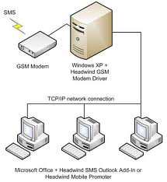

## 

## 2.8. Internet

The term internet refers to the global network of public computers running Internet Protocol. The Internet supports the public WWW and many special-purpose client/server software systems. Internet technology also supports many private corporateintranets and private home LANs

## 2.9. Web site

Is a collection of web page linked between then and stored together in order to provide information to the users. Web pages can contain text, images, videos, sounds and so on. The popular markup language used to create website and web pages is HTML (Hypertext Markup Language.)



## 2.10. Web Application.

A web application is an interactive web site which provides services to the visitors. It uses scripts which can retrieve and save information into different types of database. A web application provides responses to all users requests and user and navigates according to the needs.

## 2.11. PHP

PHP was created in 1995 by an independent software developer named Rasmus Lerdorf. His first PHP script was a Perl/CGI program that kept a log of each visitor that came to his site.

The script then displayed how many visits he had received on each page. He soon started receiving emails from other web masters across the Internet asking how he did this (a "Counter" as this is called, were very rare back then.) Because of the interest in his script he started to develop PHP into a new language, by adding more and more features to his script.

Eventually, he decided to stop programming PHP in Perl/CGI, and start constructing it with a more powerful language, "C". Thus the interest in PHP keep growing as more features were added and soon other people started writing code for it. It is now one of the most popular languages on the Internet, with contributing programmers across the world.

## 2.12. XAMPP

Is a platform which means Extended Apache Mysql PHP which is a platform which combine the Local Server Services APACHE, the popular database used online MYSQL and the interpreter of PHP Language Script. It will be used to create codes of our projects. They is also other software which support those services like WAMP, EasyPHP …

## 2.13. APACHE Server

The Apache [HTTP](http://en.wikipedia.org/wiki/Hypertext_Transfer_Protocol) Server, commonly referred to as Apache is [web server](http://en.wikipedia.org/wiki/Web_server) software notable for playing a key role in the initial growth of the [World Wide Web](http://en.wikipedia.org/wiki/World_Wide_Web) and for today Apache server is used with MySQL database to make the web site and is most married with as languages such as PHP, MySQL, XAMPP, WampServer and so on. Apache is a server used as local to make our web site.Server is known as a [computer](http://www.webopedia.com/TERM/C/computer.html) or [device](http://www.webopedia.com/TERM/D/device.html) on a [network](http://www.webopedia.com/TERM/N/network.html) that manages network [resources](http://www.webopedia.com/TERM/R/resource.html).

## 2.14 Macromedia Dreamweaver 8

The world's best way to create professional websites is now the easiest way to build powerful Internet applications. For the first time, you can work in a single environment to quickly create, build, and manage websites and Internet applications. Get the visual layout tools of Dreamweaver. The rapid web application features of Dreamweaver Ultra Dev. And the code-editing support of Home Site. All in one complete, integrated solution--Dreamweaver MX.

## 2.15 JAVA SCRIPT

JavaScript is an interpreted programming or script language from Netscape.

JavaScript is used in web site development to such things as:

* Automatically change a formatted date on a web page.
* Cause a linked-to-page to appear in a popup window
* Cause text or graphic image to change during a mouse rollover

A JavaScript program can be placed anywhere within the HTML file.

Many programmers favor placing their programs between <head> tags in order to separate the programming code from the web page content and layout and also some programmers prefer placing programs within the body of the web page at the location where the program output is generated and displayed.

## 2.16 Photoshop

It is software that used to give a format, editing, manipulating images and photos

# CHAPTER THREE: SYSTEM ANALYSIS

## 3.0 Introduction

The web based ESTG Mail Client System is realized by creating a Mysql database containing all the tables to be employed in the application then the web interface will be created using PHP programming language which also joins the database tables and enables insertion, deleting from the data. The PHP language has lots of functionalities which will be elaborated more in this book.

Apart from PHP, the web pages were designed in HTML codes and JavaScript codes which are helpful in laying out the forms and table rows and columns for presenting information as well as the data to be displayed. The web server in this case is Apache.

## 3.1 Information gathering

In order to understand how the current system operates the researcher used various techniques to gather the information which included:

### 3.1.1 Interview

Interview is a data collection method for collecting data that was conducted by presentation of oral verbal stimuli and replayed in terms of oral verbal responses. This is a widely used methodology in many disciplines. The research conducted an interview with the ESTG Leaders whereby the researcher asked the Head master with other members of ESTG, questions regarding the communication between them. Then they gave all information regarding the process which helped the researcher to understand how current system operates.

### 3.1.2 Observation

The research was taken to the location of ESTG and we entered in to get deeply all information by observing and used in order to observe how the service of ESTG is offered in order to gather more data of the system.

### 3.1.3. Documentation

This technique is the method which helps to refer to books, internet (website), magazines and findings of other researchers on the same subject of the project are consulted.

## 3.2 Description of existing system

From all information gathered and the analysis of existing system we found that there is more money used to buy pens and papers in order to send your message, and more time used when you are going to submit your message and also The process of managing ESTG using oral and paper communication consumes long time, a lot of paper used in communication.

## 3. 3 Description the proposal system

Generally, ESTG mail client system is for . Every Person that are in ESTG can send a comment in contact us menu. to send and receive messages you must have an account, and a user can’t make any change on messages or comment of another user can only delete his/her own messages. But Admin has a permission to delete or update comments.

## 3.4 software/system development model

The development models are the various processes or methodologies that are being selected for the development of the project depending on the project’s aims and goals. There are many development life cycle models that have been developed in order to achieve different required objectives. One of those models is “Waterfall model”

### 3.4.1The waterfall model

Requirement analysis & Definition (RA&D)

Implementation

Validation & Verification (V&V)

System design (SD)

#### Figure1: Waterfall model

The Waterfall Model was first Process Model to be introduced. It is also referred to as a **linear-sequential life cycle model**.  It is very simple to understand and use.  In a waterfall model, each phase must be completed fully before the next phase can begin.   At the end of each phase, a review takes place to determine if the project is on the right path and whether or not to continue or discard the project. In waterfall model phases do not overlap. **Advantages of waterfall model are** Simple and easy to understand and use, Easy to manage due to the rigidity of the model – each phase has specific deliverables and a review process, Phases are processed and completed one at a time, Works well for smaller projects where requirements are very well understood. **Disadvantages of it are** once an application is in the [**t**esting](http://istqbexamcertification.com/what-is-a-software-testing/) stage, it is very difficult to go back and change something that was not well-thought out in the concept stage, not a good model for complex and object-oriented projects, Poor model for long and ongoing projects, Not suitable for the projects where requirements are at a moderate to high risk of changing.

## 3.5. Illustration diagram

### 3.5.1 Use case Diagram for Existing System

#### 

#### Figure2: Use case diagram for the Existing system

### 3.5.2 Use case Diagram for the new System

User

Admin

-

#### 

#### Figure 3: Use case diagram for the new system.

This use case diagram is showing all the activities that have to be done by the two actors on user

## 4.1. Physical model

#### 

#### Figure4: database relationship

## 

### 

### 4.1.1 SUMMARY

## 

This chapter describes the information gathered to the existing system in order to develop the proposal system and diagrams used in proposal system.

# 

# CHAPTER FOUR: SYSTEM DESIGN AND IMPLEMENTATION OF NEW SYSTEM

## 4.0 Introduction

Design is the process of applying various techniques and principles for the purpose of defining a device, a process on a system in sufficient detail to permit its physical realization. It is a process through which requirements are translated into a representation of the software. Software design is the technical kernel of the software engineering process and is applied regardless of the development paradigm that is used.

From a project management point of view software design is conducted in two steps. Preliminary design is concerned with the transformation of requirements into data and software architecture.

Detail design focuses on refinement to the architectural representation that lead to detail data structure and algorithmic representations for software.

System design involves translating information requirements and conceptual design into technical specification and general flow of processing. After considering the requirements of the firm, needs are identified, related information is gathered to verify the problem and after evaluating the existing system, a new system is proposed .The proposed system consists of various modules, their maintenance works and finally report generation.

It has been assured that the system will have the functions and promises of the proposed system. In the design phase, various techniques are used to present a simple but efficient environment.

## 4.1 Entity Relation Diagram

ERD is a representation that illustrates the concepts of entities that exist in a system and the relationships between those entities. The entities in the ERD represent table in database, so the ERD graphic shows how entities interact and depend to each other. The relationship lines represent the keys in one table that point to specific records in the tables related

ERD is also a network model that describes stored data of a system at a high level of abstraction. For system analysis, ERD has a major benefit: it highlights the relationship between data stores on UML which would otherwise only be seen in the specification process.

The components of an ERD include:

* Entity: represented in rectangle
* Attribute: represented in ellipse
* Relationship: represented in diamond

An entity is a thing or “objects” in the real world that is distinguishable from other objects

Attributes are the characteristics of the entity displayed by fields or columns of a table.

Relationship shows connections among the system’s entities

There are 3 major types of relationship used in ERDs:

* One - one relationship
* One - many relationship
* Many - many relationship

1

N

1

1

N

N

Message

Filename

senderfolder

Receiver folder

Users

Send

Create

Account

Send

Bod

Sex

Phone no

Registrydate

Comment

1

N

#### 

#### Figure5: conceptual data model

Users_table

USER_ID Int (11)

USERNAME Varchar (35)

PWD Varchar (50)

STATUS bit (1)

Login ()

Message table

MSG_ID Int (11)

MSGFROM Varchar (30)

SUBJECT Varchar (30)

BODY Varchar (500)

MSGTO Varchar (255)

FLAG Varchar (2)

DOS Datetime

FILE Varchar (255)

FILENAME Varchar (255)

SENDERFOLDER Enum (‘sent’,’draft’,’deleted’)

RECEIVERFOLDER Enum (‘inbox’,’trash’,’deleted’)

Send message ()

Signup table

USER_ID Int (11)

FNAME Varchar (30)

LNAME Varchar (30)

ADDRESS Varchar (30)

BOD Varchar (30)

SEX Varchar (30)

PHONENO Varchar (15)

REGISTRYDATE timestamp

New account ()

Comment

Com_id Int (5)

First name Varchar (30)

Last name Varchar (30)

Email Varchar (30)

Comment Varchar (500)

DOS Datetime

Comment ()

Admin_login

Username Varchar (60)

Password Varchar (60)

Delete, update ()

Create

1

N

1

N

1

N

N

N

### 

### 4.1.1 Database processing system

It is a database technology that has been developed to ensure the relationship of users, database application, Database Management System (DBMS), and database. Database processing program call the DBMS to access the stored data. The following figure shows the representation of a database processing System.

DBMS

Database

Database

Application

#### Figure6: database processing system

The fundamental purpose of database processing system is that the application programmers do not have to be concerned with the way in which data are physically stored.

Data structuring is refined through a process called normalization. Data are grouped in simple way possible so that later changes can be made with a minimum of impact on the data structure.

The following is listing of tables used in web based ESTG Intranet Mail Client system:

**I. user**

The information of user which is registered are stored in this table.

|  |  |  |  |
| --- | --- | --- | --- |
| Field Names | Data types | Size | Description |
| USER_ID | Int | 11 | Id of user |
| USERNAME | Varchar | 35 | Name of user |
| PWD | Varchar | 50 | Password of user |
| STATUS | Bit | 1 |  |

##### Table1: user table

**ii. Create account**

**This table contain record of user that create account**

|  |  |  |  |
| --- | --- | --- | --- |
| Field Names | Data types | Size | Description |
| USER_ID | Int | 11 | Id of user |
| FNAME | Varchar | 30 | Firs name of user |
| LNAME | Varchar | 30 | Last name of user |
| ADDRESS | Varchar | 30 | Address of user |
| BOD | Varchar | 30 | Date of birth |
| SEX | Varchar | 30 | Sex of user |
| PHONENO | Varchar | 15 | Phone number of user |
| REGISTRYDATE | Timestamp | - | Registration date |

##### Table2: table of creating new account

**iii. Message**

|  |  |  |  |
| --- | --- | --- | --- |
| Field Names | Data types | Size | Description |
| MSG_ID | Int | 11 | Id of message |
| MSGFROM | Varchar | 30 | Name of sender |
| SUBJECT | Varchar | 30 | Sender’s email |
| BODY | Varchar | 500 | Object of the message |
| MSGTO | Text | 255 | Message to be sent |
| FLAG | Varchar | 2 | Sending date |
| DOS | Datetime |  | Date of sent |
| FILE | Varchar | 255 | Uploaded file |
| FILENAME | Varchar | 255 | Name of file |
| SENDERFOLDER | Enum(‘sent’,’draft’,’deleted’) |  | Name of Sender folder |
| RECEIVERFOLDER | Enum(‘inbox’,’trash’,’deleted’) |  | Name of receive folder |

##### table3: message table

**iv. Comment**

|  |  |  |  |
| --- | --- | --- | --- |
| Field Names | Data types | Size | Description |
| Com_id | Int | 5 | Id of commenter |
| First name | Varchar | 30 | First name of commenter |
| Last name | Varchar | 30 | Last name of commenter |
| Email | Varchar | 30 | Email of commenter |
| Comment | Varchar | 500 | Idea of commenter |

##### Table4: comment table

**v. Admin**

|  |  |  |  |
| --- | --- | --- | --- |
| Field Names | Data types | Size | Description |
| Ad_id | Int | 5 | Id of admin |
| Username | Varchar | 60 | Name of admin |
| Password | Varchar | 60 | Password of admin |

##### Table5: admin table

### 4.1.2 Logical design

The logical design of a system pertains to an abstract representation of the data flows, inputs and outputs of the system. This is often conducted via modeling, which involves a simplistic (and sometimes graphical) representation of an actual system. In the context of systems design, modeling can undertake the following forms:

* Data flow diagrams,
* Entity relationship diagram.

## 

## 4.2 Data Dictionary

Data dictionary describes the structure and attributes of data 'items' to be used within a software application (usually a database).

A data dictionary includes the names and descriptions of the tables and the fields contained in each table. It also documents information about the data type, field length and other things such as validation.

The main purpose of the data dictionary is to provide metadata, or information about data.  Technically, it is a database about a database.

There is no one set standard in terms of layout or the level of detail to which a data dictionary should be written.

Software development teams need a comprehensive data dictionary to refer to during the development and maintenance of a new database. This is so that they are all working using the same data formats when reading or writing data.

### 3.2.1. User data dictionary

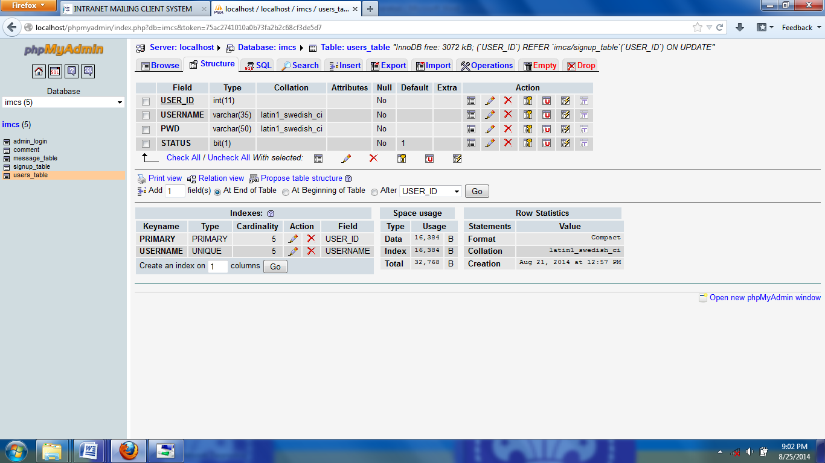

##### Table 6: user

### 4.2.2. Create Account data dictionary

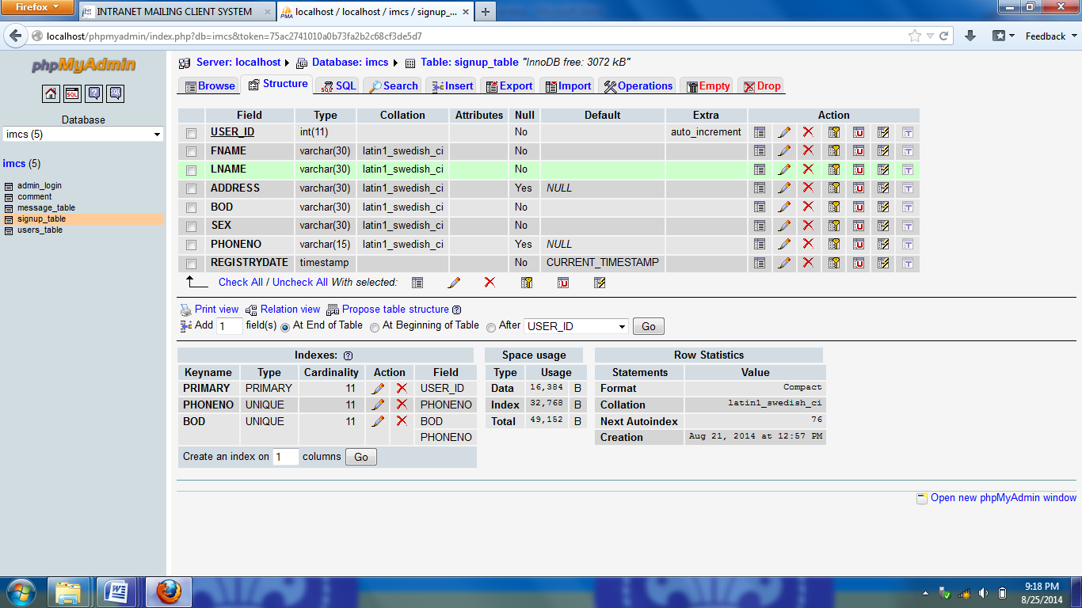

##### Table 7: create new account

### 4.2.3. Message Data Dictionary

##### Table 8: Message

### 4.2.4. Comment data dictionary

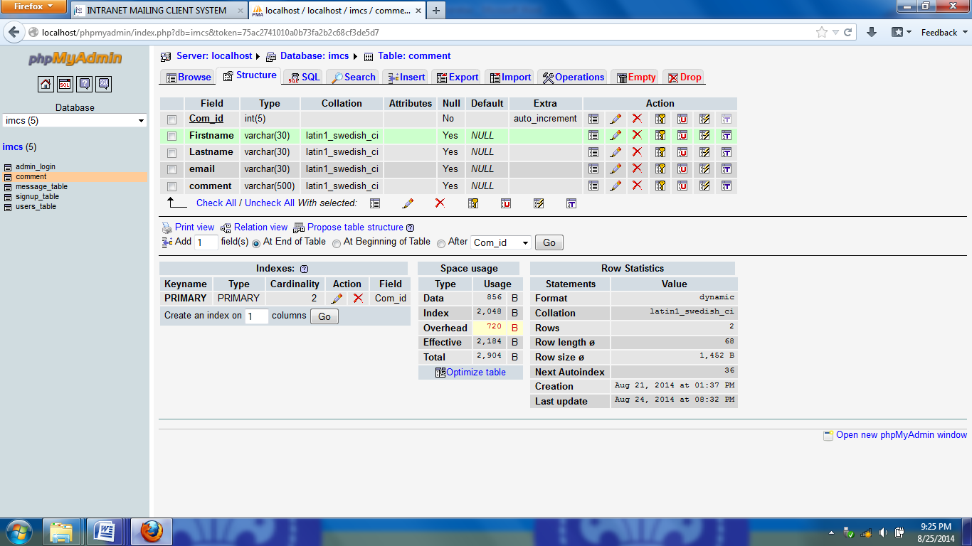

Table 9: Comment

### 4.2.5. Admin data dictionary

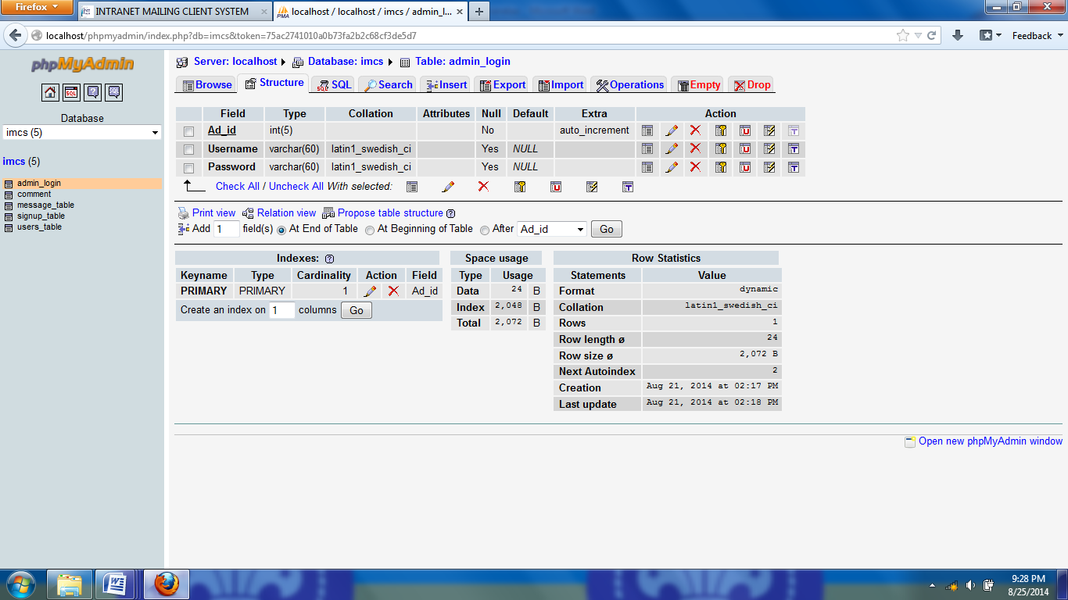

Table 10: Admin

## 

## 4.3. Architecture design

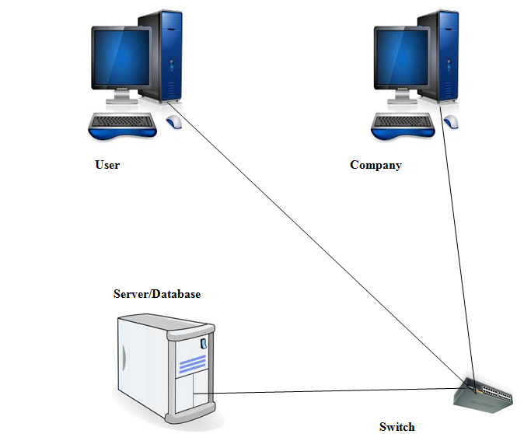

#### Figure7 :Architecture design

##### 

**EXPLANATION**

Architecture is the bigger picture: the choice of frameworks, languages, scope, goals and high-level methodologies (Rational, waterfall, agile, etc)

Design is smaller picture: the plan for how code will be organized; how the contracts between different parts of the system will look; the ongoing implementation of the projects methodologies and goals. Specification is written during this stage.

This architecture design contain different equipments like router for connecting internal network to the internet, switch for connecting different computers and serves (LAN) and servers. There are two servers, web server which will provide web services and database server which will store database.

## 4.4. REQUIREMENTS SPECIFICATIONS

### Project Requirements

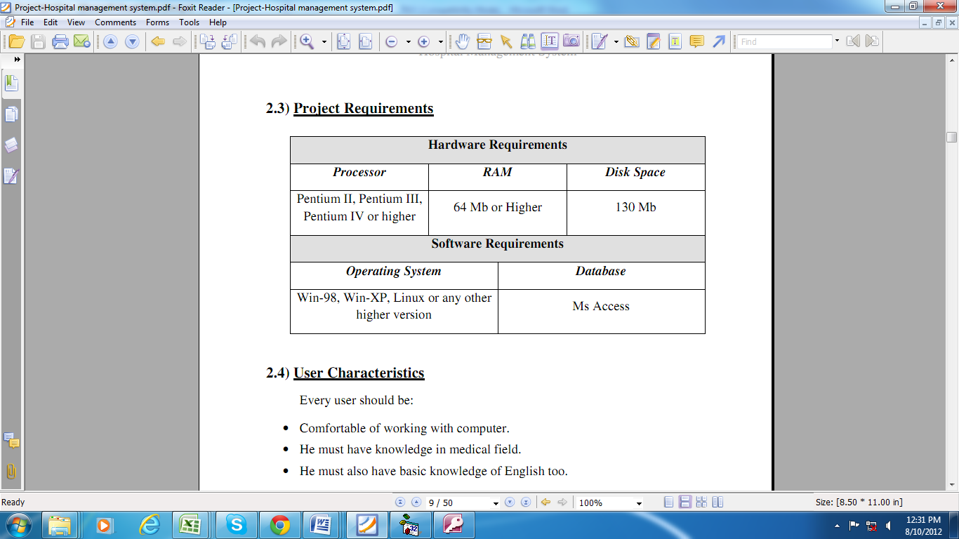

Mysql database

#### Figure8: Project Requirements

## 4.5. User Characteristics

Every user should be:

• Comfortable of working with computer.

• He must have knowledge in information communication and technology Field.

• He must also have basic knowledge of English too.

## 4.6. Constraints

• GUI is only in English.

• Login and password is used for identification of user and there is no facility for guest.

## 4.7. INTRANET ORGANISATION

An intranet Organization is used to show system’s functions that will be constructed and the implementation process of data diagram.

Moreover, intranet organization will also be used to determine the appearance frequency of smaller process in the data flow chart.

**Intranet mail client system**

**Home**

**Sign up**

**About us**

**Contact us**

**LOGIN**

**Create account**

**COMMENT**

**INFORMATIO**N

#### Figure9: intranet organization

## 4.8. Description of tools is used

This application was developed using PHP, MYSQL, CSS, HTML and Java script

**PHP**

PHP (recursive acronym for "Hypertext Preprocessor") is a widely-used Open Source general-purpose scripting language that is especially suited for Web development and can be embedded into HTML.

PHP is one of the most popular server-side scripting languages.

**MYSQL**

MySQL is an SQL (Structured Query Language) based relational database management system (DBMS)

MySQL is compatible with standard SQL

MySQL is frequently used by PHP and Perl

Commercial version of MySQL is also provided (including technical support)

**CSS**

CSS stands for (Cascading Style Sheets) is a language which gives style to Web pages.

Style Sheets is whole technologies which give style to any documents.

We can use CSS with HTML.

HTML: Which define the structure of information and meaning of each element.

CSS: Which give how to decorate this information?

**HTML**

Hypertext Markup Language (HTML) is responsible for telling a Web browser (e.g., Microsoft Internet Explorer, Mozilla Firefox, Opera, Mac Safari, Google Chrome, and so on) how text and other objects in a Web document should appear. Whether the text should be small, large, bold, underlined, or right or left justiﬁed is largely determined by the HTML embedded in a Web page.

## 4.9. SCREEN VIEWS

### 4.9.1. Login Form Description

**Application User Interface**

*This is the home page of estg intranet mail client system where user can login in system.*

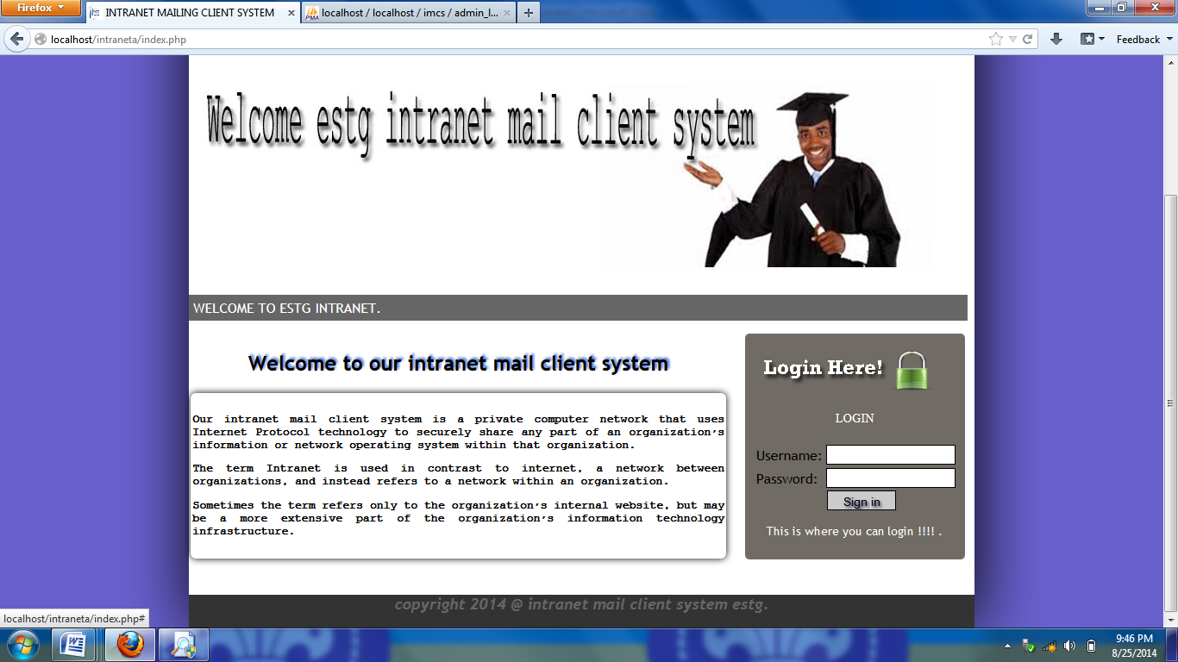

#### Figur10. Login Page

**T**he user will fill the username and password and then click login. In order to access this page, you must login first with a registered username and password. Otherwise you will not be allowed to send and receive messages.

After entering username and password you will see a message that tells you that you are” existing user” (if you don’t create an account directly) but if it is a new user you will see the message that you are” new user”.

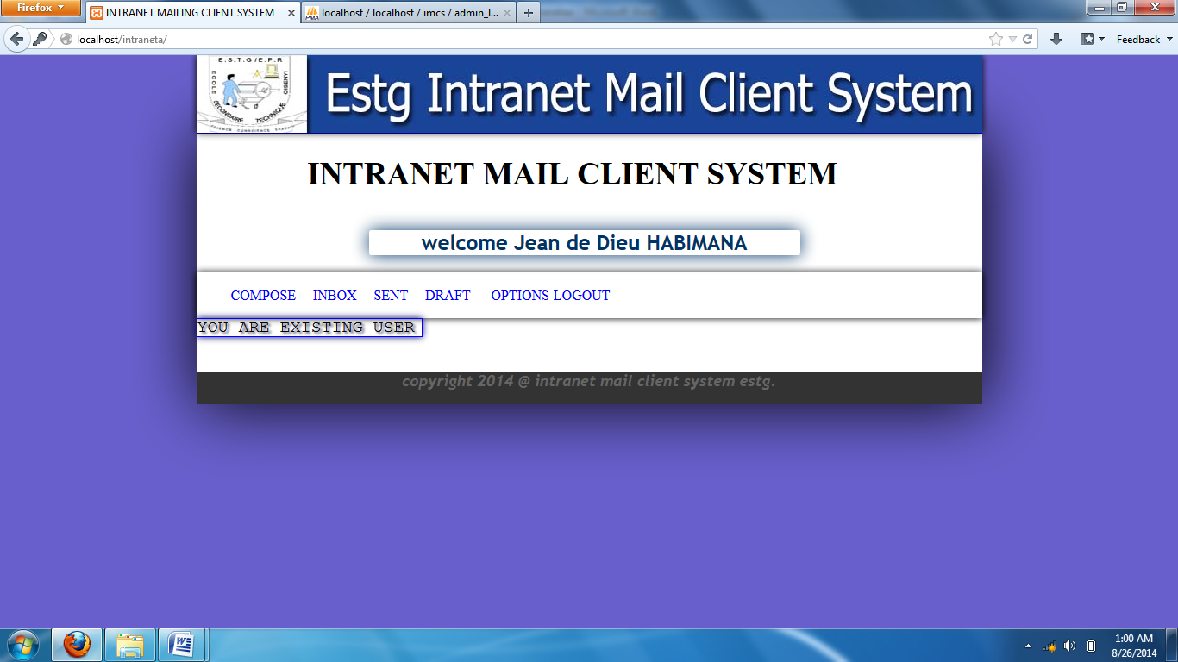

#### Figure 11: user page

**4.9.2 CREATE NEW ACCOUNT**

*This is where user can create a new account with filling the fields required*

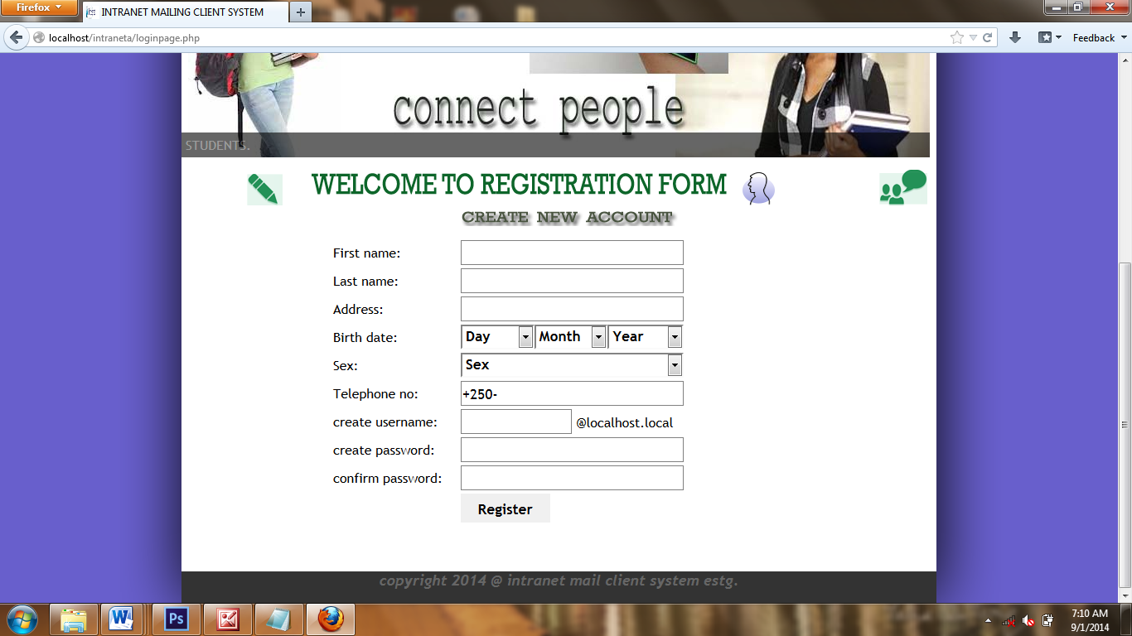

#### Figure12: create account

The registered user will click New account and fill by entering first name then fill the last name , fulfill the address, select your date of birth, select sex and write your phone number, your phone number must be nine after +250 as code for Rwanda, fill your username that you will use to communicate with others, fill password you will use and your password must not be less than eight and confirm your password by reenter the password you have entered and then click on register.

**4.9.3 ABOUT US**

*This page display information about*

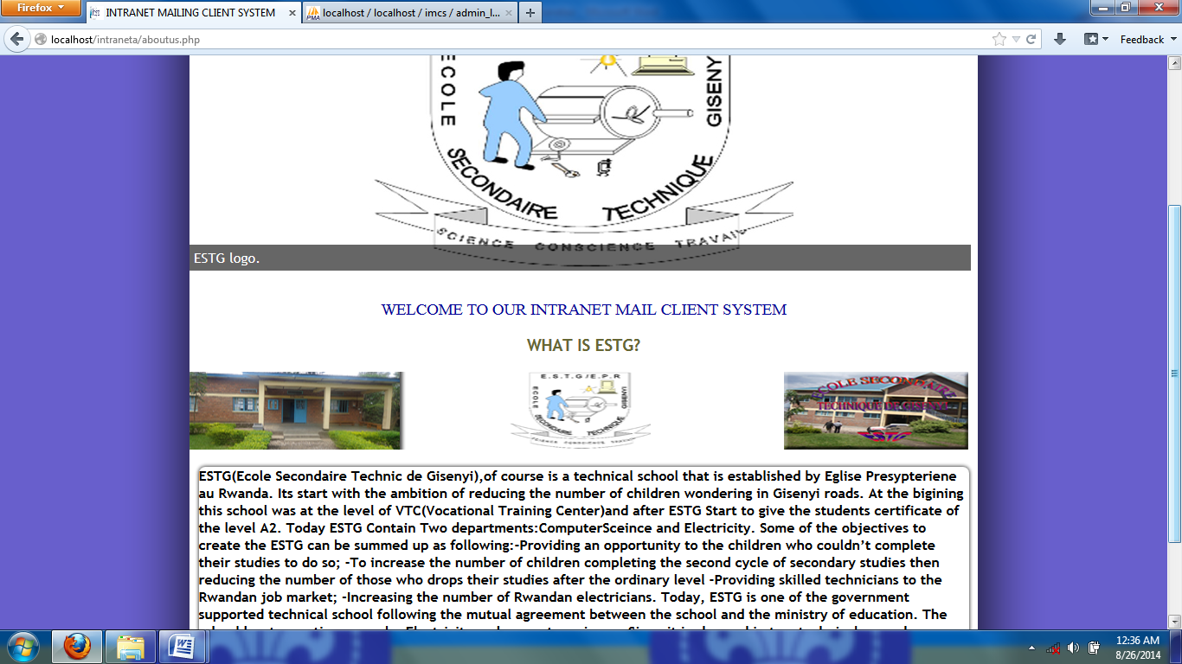

#### Figure 13: about us

### 4.9.4 CONTACT US

*This page allows the entire user to comment on system even if the user does not have an account or have***.**

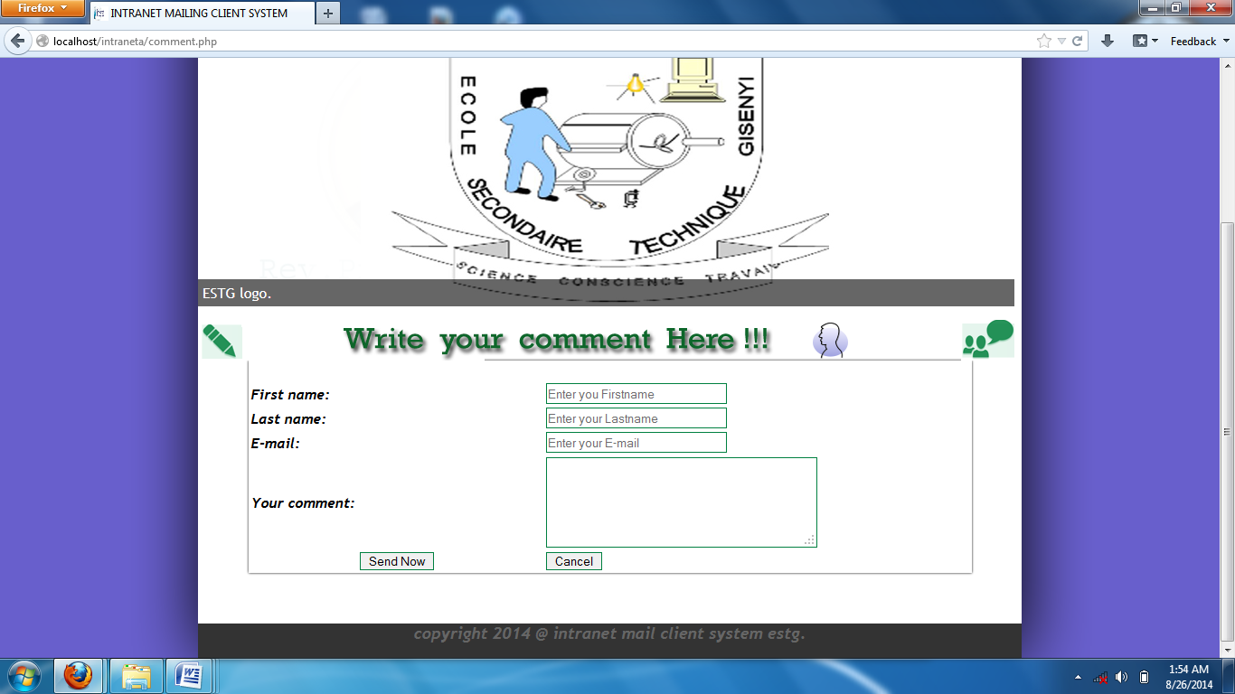

#### Figure14: contact us

### 4.9.4 COMPOSE EMAIL MESSAGE

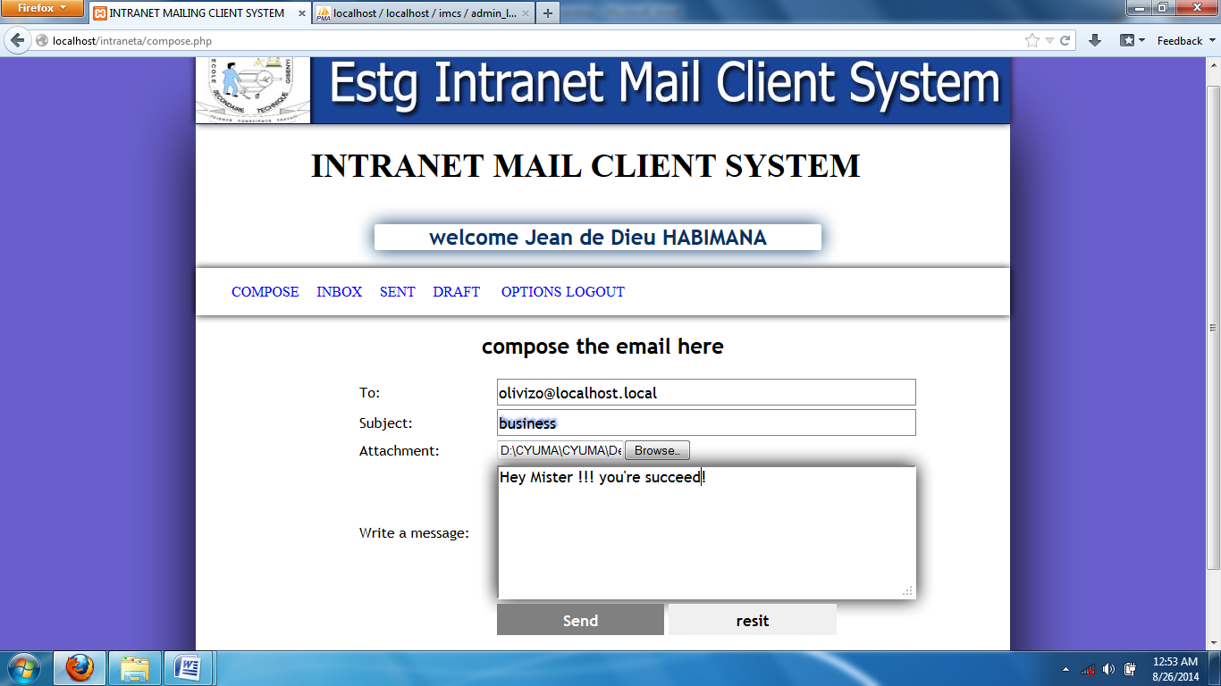

#### Figure15: compose a message

The User will fill all fields and on attachment you will browse in order to find whatever you want to attach. After click Send to send your message. If message sent you will see a message like below.

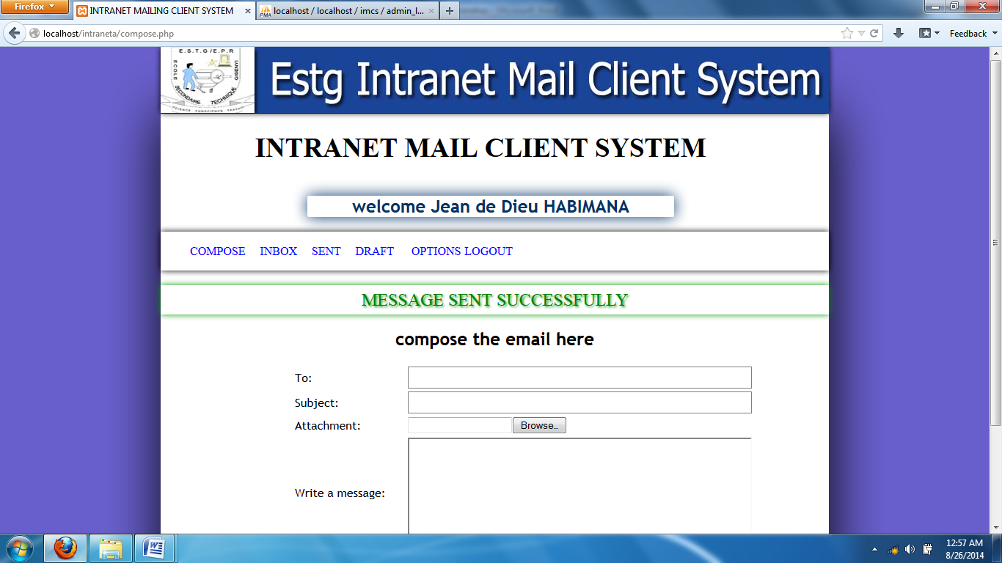

### 4.9.5 Inbox

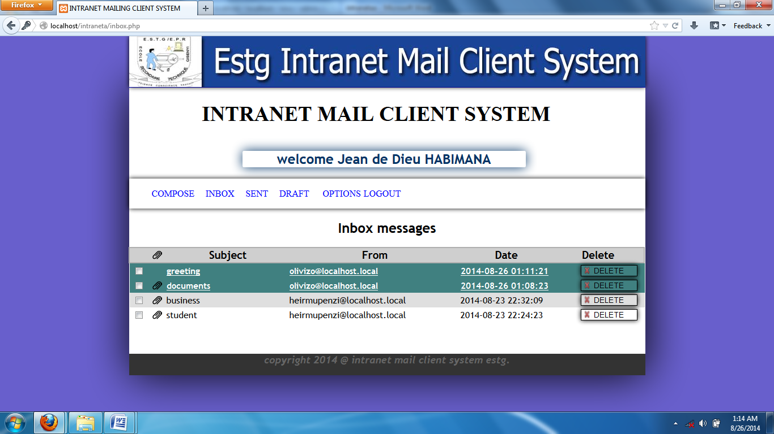

Figure 16: inbox

#### 

When you want to see the received messages, you will click on inbox and you will see an interface like above, a new received message is shown in green white color with underline message subject from and date .you may delete it, forward and even reply, by clicking on that message.

### 4.9.6 SENT

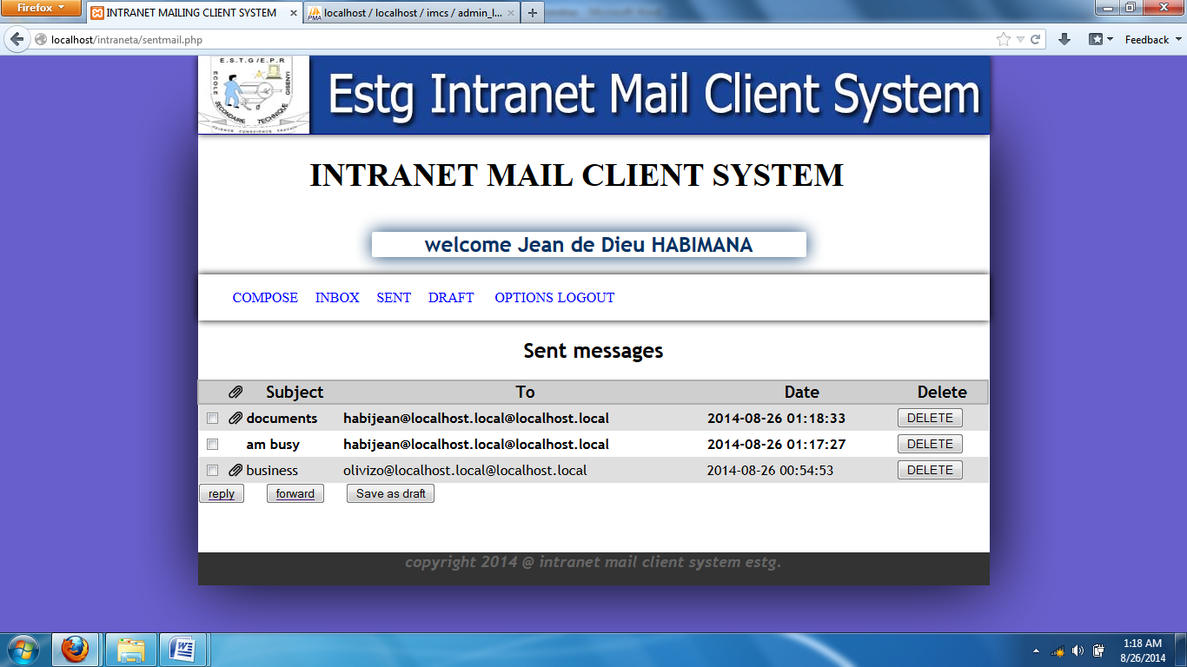

#### Figure 17: sent message

When you want to see the sent messages, you will click on sent and you will see an interface like above, and you may delete it, forward and even reply, by clicking on that message.

### 4.9.7 ADMIN

Here an admin has an important of managing the system comment

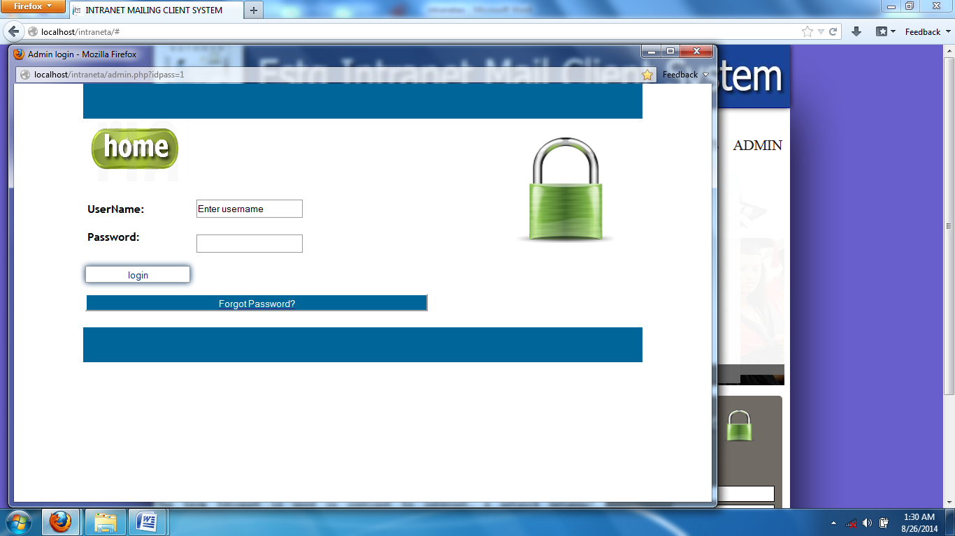

#### Figure 18.admin

Here an admin has right to delete or update comment if it necessary

# 

# CHAPTER FIVE: CONCLUSION AND RECOMMANDATION.

## 5.1. Conclusion

As conclusion, the use of Information Technology in different management and other operations is very important in the increment of the performance and usability.

ICT can be used as a tool of communication if all other companies have an intranet system which will be useful and very important to it.

There is other thing that is not completely done because of short time and tools.

# 5.2. Recommendation

## To WDA

* To include a courses of Research and Projects management in the courses learnt in senior six to allow students to be able to prepare projects them self.
* To provide a training to teachers so that they can help us in different project activities.

## To ESTG

* To continue the training they provide to students in technical options
* To prepare students for the action of project implementation since the first term.
* To increase the knowledge for the trainers
* To ESTG junior students, complete the work that is not completely well.

**REFERENCES**

**ELECTRONIC REFERENCES**

1. www.commentcamarche.com
2. www.commentcamarche.net
3. http://en.wikipedia.org/wiki/Data_flow_diagram
4. Www. Kashipara.com
5. http://www.businessdictionary.com/definition/information-system.html

http://www.inc.com/encyclopedia/management-information-systems-mis.html

7. http://en.wikipedia.org/wiki/Scripting_language

8. http://en.wikipedia.org/wiki/HTML

9. http://en.wikipedia.org/wiki/PHP

10. http://php.net/manual/en/intro-whatis.php

**BOOKS**

1. “An Integrated ICT-led Socio-Economic Development Policy and Plan for Rwanda’’.